Ebram Rasmy
Abache – lab2

8- lab1
Create folder os.iti.gov.eg and Create the index.html
Create the VirtualHost file
Enable the VirtualHost file
Add the domain to /etc/hosts
Restart Apache

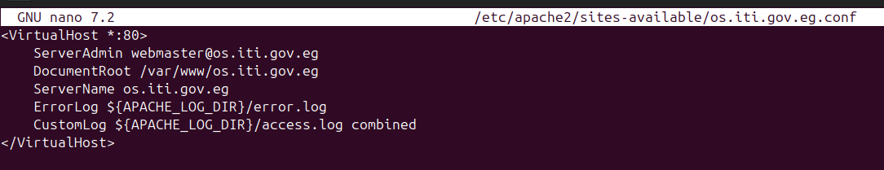
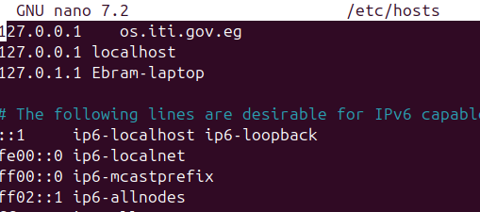

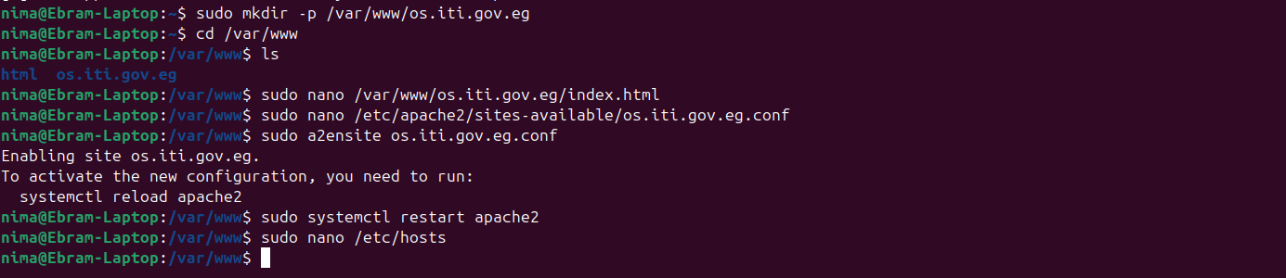

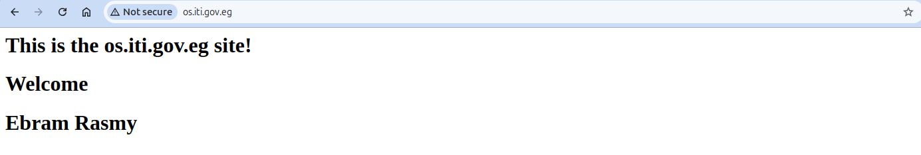
9-

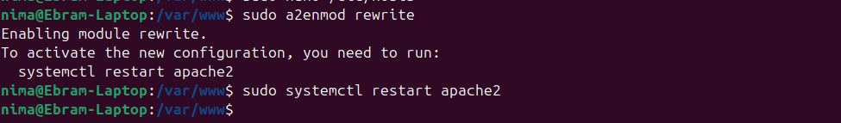
10-
The mod_rewrite module is extremely important because it provides powerful and flexible URL manipulation capabilities in the Apache HTTP Server. It allows administrators to modify, redirect, and transform incoming URL requests based on defined rules.

-Improving SEO and user experience.
-Enhancing security and access control.
-Managing URL redirections and canonicalization.
-Handling dynamic content and routing.
-By leveraging mod_rewrite, you can create a more robust, secure, and user-friendly web application.

1- lab2
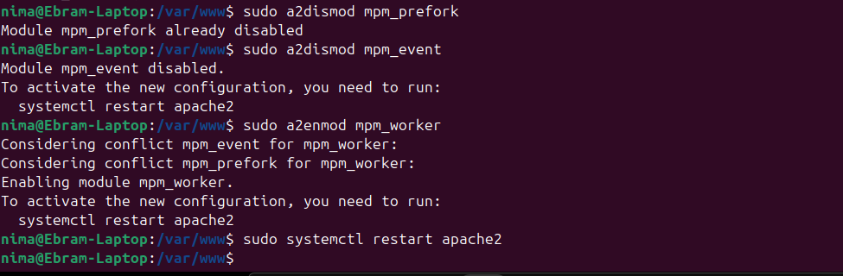

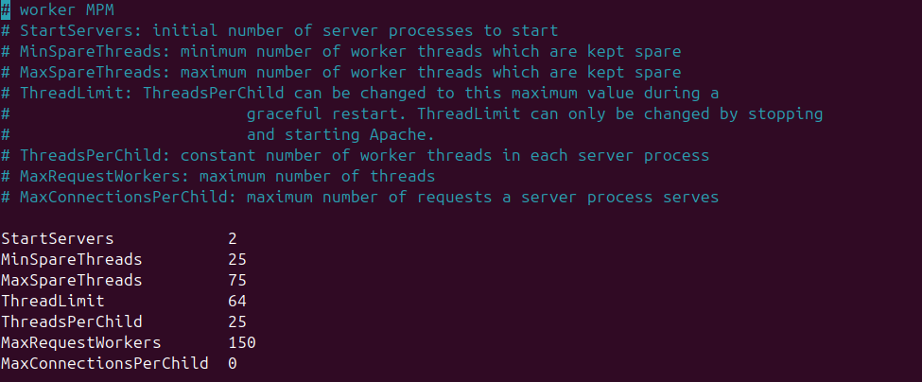
.

2-
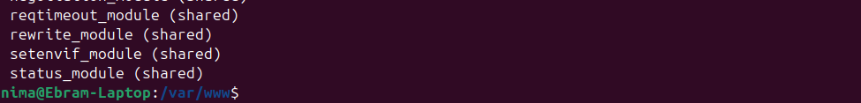
.
3-

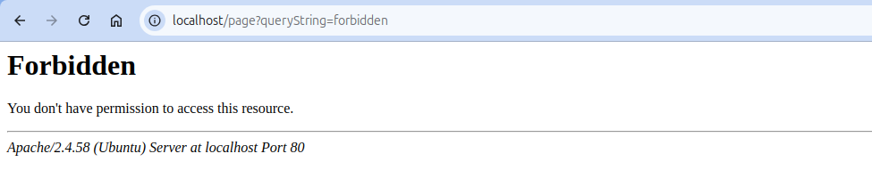
a.
b.

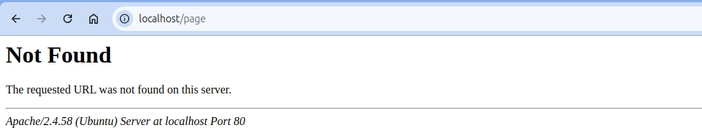

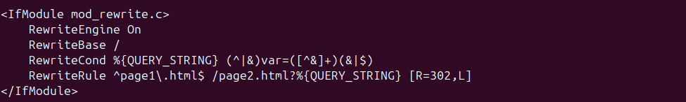
c-
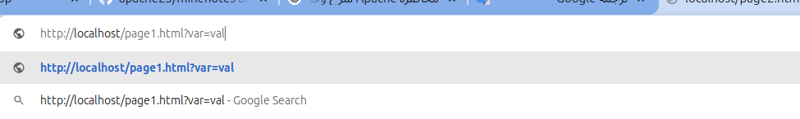
.

Redirected to page 2 of lab 1

d-

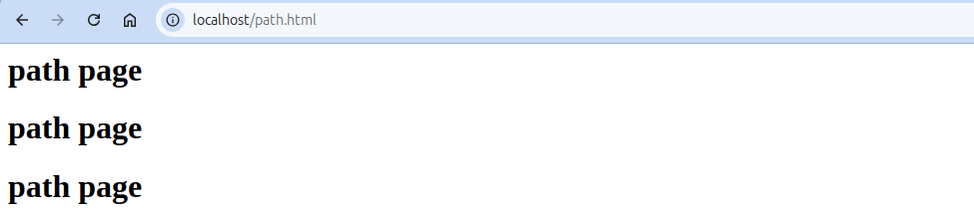
.
e-

f- Bonus
We will use a property => %{TIME_HOUR}.
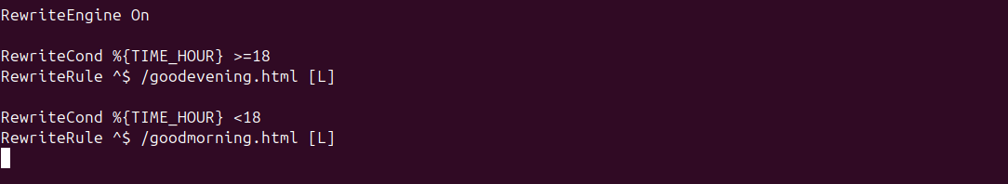
Create goodmorning.html and goodevening.html
.
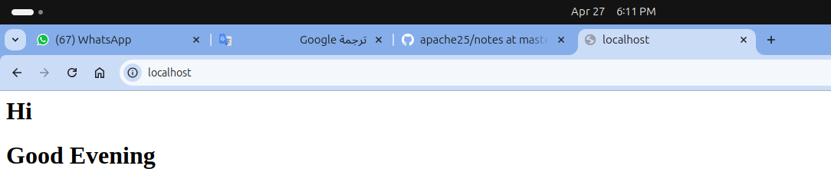
.
4-Same question number 8 in lab 1, same steps

